# Purpose

Household and housing stock characteristics, both past and present, can be examined to assess whether a community is providing an adequate housing supply to meet the needs of its residents. This section of the Comprehensive Plan describes and analyzes the Town of Dellona’s primary housing characteristics such as the number of housing units, occupancy rate, structural type, age and value of existing housing structures, and household income and expenses. This section also describes what constitutes ‘affordable’ housing and includes objectives and policies to facilitate a housing supply that provides a range of housing opportunities. Portions of this chapter refer to ***Chapter 3: Population Inventory and Analysis.***

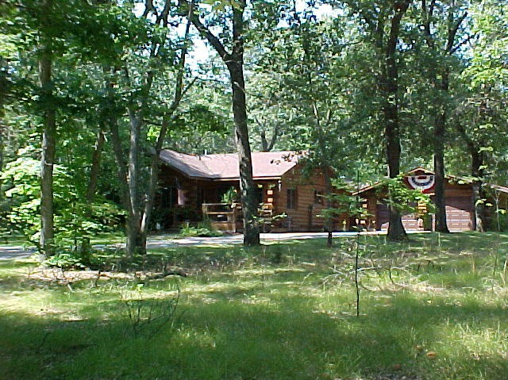

# Demographic Housing Summary

The number of housing units in the Town of Dellona have more than doubled in the last 30 years, rising from 400 in 1990 to 871 housing units in 2020 according to the U.S. Census. The average household size has remained relatively stable since 1990 and is slightly higher than the County average at 2.71 which indicates there are more family households in the Town. As noted in **Table H3: Households by Type**, the Town of Dellona has approximately 10% more of its population living in family households than the County overall. However, the number of family households and single-family households has seen a decrease in the last decade. With the rise in housing units, this indicates an increase in housing units utilized for rentals and seasonal occupation. There has also been a slight increase in mobile homes and multi-unit housing. The majority of the housing stock (76.2%) was constructed after 1980, significantly newer the housing stock throughout the County. Also, the average home value is higher than the average for Sauk County with over 55% of the homes valued greater than $200,000. Along with home values, the Census notes a higher distribution of household income for the Town, with a median household income of $73,663 and 62.2% of households at or above the median income. The income level in Dellona is, on average, higher than that of Sauk County and the state of Wisconsin. Since 2010, the Town has experienced a decrease in household expenses. Monthly household costs are less for residents of the Town than the County for both mortgaged homes and rentals. Overall, housing appears to be affordable in the Town, offering a range of housing options and costs.

# Housing Unit Trends

|  |  |  |  |  |  |  |  |  |  |  |  |  |  |  |  |  |
| --- | --- | --- | --- | --- | --- | --- | --- | --- | --- | --- | --- | --- | --- | --- | --- | --- |
| **Chart H1: Regional Housing Unit Comparison** | | | | | | | | | | | | | | | | |
| **YEAR** | **Town of Dellona** | | **Town of Winfield** | | **Town of Excelsior** | | **Town of Delton** | | **Town of Seven Mile Creek** | | **Town of Lyndon** | | **Sauk County** | | **Wisconsin** | |
| **#** | **% Change** | **#** | **% Change** | **#** | **% Change** | **#** | **% Change** | **#** | **% Change** | **#** | **% Change** | **#** | **% Change** | **#** | **% Change** |
| 1990 | 400 |  | 228 |  | 439 |  | 777 |  | 155 |  | 412 |  | 20,439 |  | 2,055,774 |  |
| 2000 | 498 | 24.50% | 297 | 30.26% | 558 | 27.11% | 862 | 10.94% | 168 | 8.39% | 534 | 29.61% | 24,297 | 18.88% | 2,321,144 | 12.91% |
| 2010 | 764 | 53.41% | 359 | 20.88% | 671 | 20.25% | 1098 | 27.38% | 203 | 20.83% | 733 | 37.27% | 25,192 | 3.68% | 2,279,768 | -1.78% |
| 2020 | 871 | 14.01% | 372 | 3.62% | 680 | 1.34% | 1078 | -1.82% | 196 | -3.45% | 730 | -0.41% | 30,784 | 22.20% | 2,727,726 | 19.65% |

*Source: U.S. Census Bureau 1990-2020*

# Household Characteristics

|  |  |  |  |  |  |  |
| --- | --- | --- | --- | --- | --- | --- |
| **Average Household Size - Persons Per Household** | | | | | | |
| **YEAR** | **Town of Dellona** | | **Sauk County** | | **Wisconsin** | |
| **#** | **% Change** | **#** | **% Change** | **#** | **% Change** |
| 1990 | 2.84 |  | 2.61 |  |  |  |
| 2000 | 2.84 | 0.00% | 2.51 | -3.83% |  |  |
| 2010 | 2.61 | -8.10% | 2.43 | -3.19% | 2.43 |  |
| 2020 | 2.71 | 3.83% | 2.53 | 4.12% | 2.51 | 3.29% |

*Source: U.S. Census Bureau, 1990-2020*

*Source: U.S. Census Bureau, 1990-2020*

|  |  |  |  |  |  |  |  |  |
| --- | --- | --- | --- | --- | --- | --- | --- | --- |
| **Table H3: Households by Type** | | | | | | | | |
|  | **Town of Dellona** | | | | **Sauk County** | | | |
| **2010** | **% of Total** | **2020** | **% of Total** | **2010** | **% of Total** | **2020** | **% of Total** |
| **Family Households** | 492 | 82.8% | 439 | 73.9% | 16,429 | 67.1% | 16,567 | 64.8% |
| Married | 437 | 73.6% | 363 | 61.1% | 13,107 | 53.5% | 13,131 | 51.4% |
| Other | 55 | 9.3% | 76 | 12.8% | 3,322 | 13.6% | 3,436 | 13.4% |
| **Non-family households** | 102 | 17.2% | 155 | 26.1% | 8,059 | 32.9% | 8,990 | 35.2% |
| Living Alone | 74 | 12.5% | 104 | 17.5% | 6,675 | 27.3% | 7,391 | 28.9% |
| Not Living Alone | 28 | 4.7% | 51 | 8.6% | 1,384 | 5.7% | 1,599 | 6.3% |
| **Total Households** | 594 | 100.0% | 594 | 100.0% | 24,488 | 100.0% | 25,557 | 100.0% |

*Source: American Community Survey, 2010, 2020*

# Housing Stock Characteristics

|  |  |  |  |  |
| --- | --- | --- | --- | --- |
| **Table H4: Housing Units by Structural Type** | | | | |
|  | **Town of Dellona** | | **Sauk County** | |
| **2010** | **2020** | **2010** | **2020** |
| **Occupied Housing Units** | 594 | 594 | 25,438 | 30525 |
| **% Single Family** | 88.4% | 81.3% | 73.1% | 67.0% |
| **% Mobile Home** | 7.7% | 11.1% | 7.7% | 6.3% |
| **% With 2-4 Units** | 3.8% | 3.4% | 8.8% | 9.5% |
| **% With 5-9 Units** | 0.0% | 1.9% | 4.7% | 5.5% |
| **% With 10 or More Units** | 0.0% | 2.4% | 5.6% | 8.5% |

*Source: American Community Survey, 2010, 2020*

|  |  |  |  |  |
| --- | --- | --- | --- | --- |
| **Table H5: Age of Existing Housing Structures, 2020** | | | | |
|  | **Dellona** | | **Sauk County** | |
| **Year Built** | **# of Units** | **Percentage** | **# of Units** | **Percentage** |
| **1939 or earlier** | 35 | 5.90% | 6,096 | 19.97% |
| **1940 - 1959** | 17 | 2.90% | 3,133 | 10.26% |
| **1960 - 1979** | 90 | 15.20% | 6,314 | 20.68% |
| **1980 - 1999** | 251 | 42.30% | 8,600 | 28.17% |
| **2000 - 2009** | 190 | 32.00% | 5,088 | 16.67% |
| **2010 - 2013** | 0 | 0.00% | 511 | 1.67% |
| **2014 or Later** | 11 | 1.90% | 783 | 2.57% |
| **Total Units** | 594 |  | 30,525 |  |

*Source: American Community Survey, 2020*

*Source: American Community Survey, 2020*

* 1. **Housing Affordability**

# *Source: American Community Survey, 2020*

|  |  |  |  |
| --- | --- | --- | --- |
| **Table H8a: Affordable Housing Expenses per Income, Dellona 2010** | | | |
| **Household Median Income (HMI) = $62,929** | | | |
| **Household Income Category** | **Rounded Description** | **Percent of Households** | **Affordable housing payment per month based on 30% of income standard** |
| **Extremely low income**  (below 25% of HMI) | $15999 or less | 4.5% | $400 |
| **Very low income**  (25% to 50% of HMI) | $16,000 - $31,999 | 12.3% | $400 - $800 |
| **Low income**  (50% to 80% of HMI) | $32,000 - $49,999 | 16.7% | $800 - $1,250 |
| **Moderate to high income**  (80% to 100% or greater of HMI) | $50,000 - $62,999 | 31.0% | $1,250 - $1,575 |
| **High income**  (greater than 100% HMI) | >$63,000 | 35.5% | $1,575 or less |

# *Source: American Community Survey, 2010*

|  |  |  |  |
| --- | --- | --- | --- |
| **Table H8b: Affordable Housing Expenses per Income, Dellona 2020** | | | |
| **Household Median Income (HMI) = $73,663** | | | |
| **Household Income Category** | **Rounded Description** | **Percent of Households** | **Affordable housing payment per month based on 30% of income standard** |
| **Extremely low income**  (below 25% of HMI) | $18,999 or less | 10.1% | $460 |
| **Very low income**  (25% to 50% of HMI) | $19,000 - $36,999 | 7.6% | $460 - $921 |
| **Low income**  (50% to 80% of HMI) | $37,000 - $58,999 | 10.9% | $925 - $1,474 |
| **Moderate income**  (80% to 100% of HMI) | $59,000 - $73,663 | 9.2% | $1,474 -$1,841 |
| **High income**  (greater than 100% HMI) | >$73,663 | 62.2% | $1,841 or less |

# *Source: American Community Survey, 2020*

# *Source: American Community Survey, 2020*

# *Source: American Community Survey, 2020*

# Housing Density

Housing density, in its simplest terms, is the ratio of housing units per total area of land. This value is commonly referred to as gross density. “Density policy”, on the other hand, can be described as a community’s desired ratio of housing units and/or lots created per unit of land area (e.g. one lot per five acres), combined with an optimum size for each building lot. Density policies often provide a credit to developers permitting additional units or lots in exchange for a reduction in the size of each lot, for the purpose of utilizing the land more efficiently and preserving adjacent land resources. The density policy can then yield a calculation of the total number of potential of future houses until an endpoint (total buildout) is reached. The current gross housing density of the Town of Dellona stands at approximately 1 residence per 26 acres.

# Local Population and Housing Trends

Population and household size are the factors that will drive housing development in the Town of Dellona. Household size remained relatively constant since 1990 when household size was 2.84 and now in 2020 only reduced to 2.71 persons per household. Should the average household size decrease in the Town, which is generally the trend in Sauk County, the number of housing units needed to accommodate the population may increase further. From 2000 to 2020, the Town experienced a 42.8% increase in housing units, from 498 in 2000 to 871 units in 2020. However, due to the high volume of seasonal homes in the area (i.e. Christmas Mountain) it’s important to look at home-occupancy in the same time-period as the increase in housing units are being observed. In 2000 it was reported that 84.7% or 422 housing units were occupied in 2000 and 81.3% or 708 housing units were occupied in 2020. This is only a 3.4% decrease in occupancy, but it should be noted that the Covid-19 pandemic in 2020 may have skewed occupancy rates in rural areas such as the Town of Dellona. If this trend continues, an additional 186 housing units will be built by the year 2030, and another 373 by 2040.

# Projected Housing Needs Based on Population Projections

As noted in ***Chapter 3 Population Inventory and Analysis*** three methods of population projections are utilized. The analysis of population growth was presented in Ch. 3, Population, along with an analysis of population growth resulting from changes in household numbers and characteristics. Below we utilize the linear projection model to show how changes in household characteristics may change housing units needed for future population changes.

# Household characteristics impacting population growth include the following:

* + - * **Static Household Size** accounts for the historic change in persons per household, or relatively little change in this situation with a current household size of 2.71 and an occupied housing rate of 84.1% in the Town. Combining these factors with the linear population projection of 2,456 persons by 2030 and 3,173 by 2040 translates to 206 new housing units by 2030 and 521 new housing units by 2040.
      * **Limited Household Size** holds the County average of 2.52 persons per household constant, this method yields an increased need for 288 houses by 2030 and a need for 626 houses by 2040.
      * **Household Size Trend** adjusts the average household size based on a 3% decrease every 10 years. For example, this projection assumes that from the year 2020 to 2030, average household size would decrease from 2.71 persons per household to 2.63 persons per household. This method yields a need for 239 additional houses by 2030 and 609 houses by 2040.

# Housing Opportunities

The Town of Dellona has always provided options for varying housing choices and locations. Some of these lots, for example within the Dellwood subdivision, were platted prior to the establishment of minimum lot size standards, and although they can support a residential structure and sanitary system, the area of these lots may be severely limited. New development may require the combination of two or more of these substandard lots to provide adequate space for a residence, and for a primary sanitary treatment system and backup, secondary treatment area.

In addition to the Town’s existing subdivisions, rural lots have historically been created by Certified Survey Map to accommodate rural residences and farmette operations. The creation of these ‘rural lots’ has served to provide an alternative living option to locating in an existing subdivision. A preliminary analysis prepared by the Sauk County Land Resources and Environment Department indicates that there are already over 138 undeveloped subdivision and Certified Survey Mapped lots in the Town of Dellona.

# Additional Housing Opportunities

New development may result from Certified Survey Map (CSM) divisions or the creation of either conventional or conservation subdivisions. The Town of Dellona has adopted a density policy of one house/lot per 5 acres within its Primary Development Area that must be applied to conventional subdivisions. Conservation subdivision design allows for higher density development, but restricts it to 60% of the total land area of the subdivision. Environmentally or culturally sensitive land cannot be developed in conservation subdivisions, and at least 40% of all the land must be protected.

# Conservation Subdivision Design

**Advantages of Conservation Subdivisions**

(compared with conventional layouts)

**Economic Advantages (for the municipality)**

* Open space enhances the municipality’s quality of life, one of the chief assets in attracting quality businesses and in encouraging economic growth.
* Municipal service provision is cheaper when homes are not widely scattered.

**Economic Advantages (for the developer)**

* Development costs are reduced as utility lines, streets and driveways are shorter.
* Conservation subdivisions (may) have marketing and sales advantages, as buyers prefer lots close to and facing protected open space.
* Homes in conservations subdivision tend to appreciate faster than counterparts in conventional subdivisions. Existing homes in conventional subdivisions adjacent to conservation subdivisions may also appreciate faster.

**Environmental Advantages (for water quality)**

* Common open space can be designated as buffers to protect wetlands, streams and lakes.
* Water quality is enhanced when impervious surfaces such as streets, driveways and pipes are minimized.
* Where appropriate, storm water and sewage treatment facilities can be located within the open space.

**Environmental Advantages (for wildlife)**

* Common open space, if properly sited and managed can provide wildlife habitat.
* When linked to other existing open spaces, the common open spaces can serve as wildlife corridors and unfragmented wildlife preserves.
* Common open space can be used to protect “unique or fragile” habitat.

**Social and Recreational Advantages**

* Common open space provides attractive areas for neighbors to meet informally and socialize.
* Common open space may be designated for recreational uses such as biking, walking or ball playing all of which promote social interaction.
* Smaller yards can provide residents with more leisure time.

Source: University of Connecticut Cooperative Extension NEMO Project and The Natural Lands Trust: All about conservation subdivision design.

The Town of Dellona encourages high-quality design and layout for newly platted residential subdivisions. This includes providing space necessary for “open space corridors” within and between successive developments, planning interconnectivity of roads between developments, and reducing the infrastructure costs associated with development. As part of high-quality design, this plan encourages the use of ***Conservation Subdivision Design*** in the planning and development of subdivisions. Conservation subdivision design is in accordance with the vision and goals of this plan, incorporating the preservation of open space and rural character as well as protecting water quality.

Conservation subdivision design provides a residential living opportunity unique to south-central Wisconsin counties. See also ***Chapter 11 Land Use*** for Steps on siting new development pertaining to developing Conservation Subdivisions.

The following Conservation Subdivision Design guidelines are recommendations, and are not mandated by the Town:

* Preserve open space features such as farmland, natural features that define the area, environmentally sensitive areas and other areas that enhance the rural character.
* Promote the rural character by limiting the visibility of new development from main roads. Topography, vegetation, and setback requirements all aid in reducing development visibility. Where features like hills and trees are absent, the use of natural plantings can be effective. In general, lots should not be placed at the entrance to subdivisions, because they would be highly visible from the main public right-of-way.
* Incorporate a road/trail network to connect homes to each other. Also, connect streets among developments. Open space in one development should connect to open space in adjacent developments.
* Encourage the creation of smaller lots that are clustered on the buildable portion of a property, allowing for the preservation of open space. Identify soils best suited for community septic systems and storm water detention and set these areas aside as common open space with shared community facilities.

# Figure H18 Example of a Conservation Subdivision Compared to a Conventional Subdivision

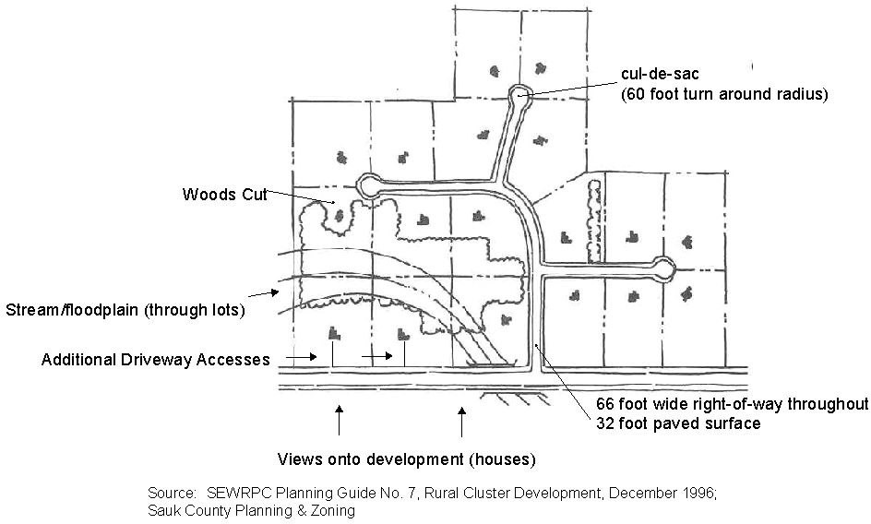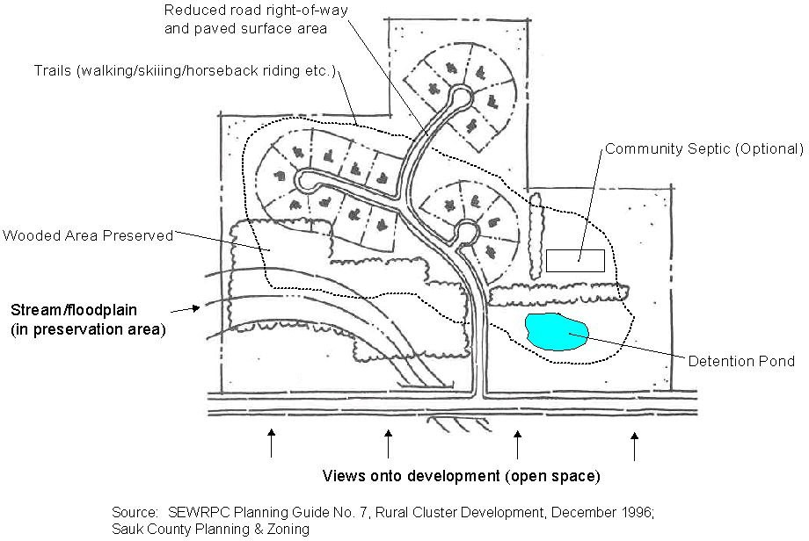

Conservation subdivisions designate forty percent or more of the original parcel as open space, while still maintaining the same number of lots that would otherwise be permitted under a conventional subdivision. A community may also choose to give “bonus” lots to developers to encourage the use of conservation subdivisions over conventional design. The Town of Dellona has adopted a density policy for conventional subdivisions that does not apply to conservation subdivisions, giving developers an incentive to create conservation subdivisions. In conventional subdivisions, developers are allowed to build at a maximum density of one house/lot per 5 acres. In conservation subdivisions, developers can build at a density of one house/lot per acre on 60% of the land. While 40% of the land in a conservation subdivision must be protected, developers are still able to create more lots on the remaining 60% than they would be able to in a conventional subdivision. In conservation subdivisions, open space can be owned and managed by any combination of the following:

* A private individual may hold fee title to the open space lands and manage the land for open space uses such as farming or hunting. Often the open space lands have a conservation easement to assure homeowners in the conservation subdivision that the land will remain as open space.
* A homeowner’s association composed of lot owners in the development would own a percentage interest in the open space and manage it through a declaration of covenants. This method of open space ownership permits residents the greatest degree of control over management of the open space.
* A non-profit land trust organization may take title or other interest in the open space lands to protect natural, productive or scenic values of the land.
* A government agency might utilize the land for public recreation.

# Figure H19 Example of an Actual Conservation Subdivision (Woodson Place, Rains County, Texas)

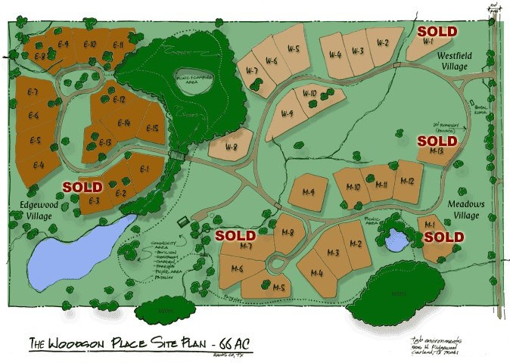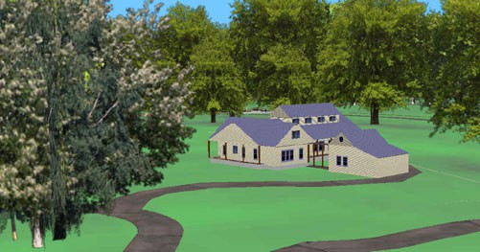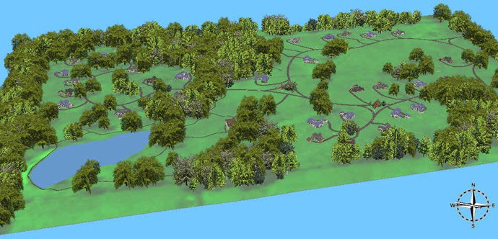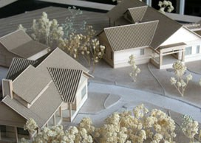

Source: Woodson Place [www.woodssonplace.com,](http://www.woodssonplace.com/) GeoData services, Inc. [www.geodata-mt.com](http://www.geodata-mt.com/)

# Housing Programs and Resources

Listed below are some examples of housing assistance programs available to Town of Dellona residents:

# U.S. Department of Housing and Urban Development (HUD)

**Section 811** – provides funding to nonprofit organizations for supportive housing for very low-income persons with disabilities who are at least 18 years of age.

**Section 202** – provides funding to private nonprofit organizations and consumer cooperatives for supportive housing for very low-income persons age 62 and older.

**Section 8** – major program for assisting very low income families, elderly and disabled individuals to afford housing on the private market. Participants are responsible for finding their own housing. Funding vouchers are distributed through Public Housing Authorities that deliver the vouchers to eligible applicants.

**Section 8/SRO** – provides funding to rehabilitate existing structures to create single room occupancy (SRO) housing with shared spaces for homeless individuals of very low income.

**Hope VI** – provides grants to Public Housing Authorities to destroy severely distressed public housing units and replace them with new units or dramatically rehabilitate existing units. It hopes to relocate residents in order to integrate low and middle-income communities. It also provides community and supportive services.

**Public Housing** – the goal is to provide rental housing for low-income families, elderly and disabled individuals. Rents are based on resident’s anticipated gross annual income less any deductions.

**HOME** – provides formula grants to states and localities that communities use to fund a range of activities that build, buy, or rehabilitate affordable housing units for rent or ownership.

**Section 502** – makes loans to low and very low-income households in rural areas to build, repair, renovate, or relocate houses, including mobile/manufactured homes. Funds can be used to purchase and prepare sites and to pay for necessities such as water supply and sewage disposal.

**Section 515** – provides direct, competitive mortgage loans to provide affordable multifamily rental housing for very low, low and moderate-income families, and elderly

and disabled individuals. It is primarily a direct mortgage program but funds can also be used to improve land and water and waste disposal systems.

**Section 514/516** – loans and grants used to buy, build, improve, or repair housing for farm laborers, including persons whose income is earned in aquaculture and those involved in on-farm processing. Funds can be used to purchase a site or leasehold interest in a site, to construct or repair housing, day care facilities, or community rooms, to pay fees to purchase durable household furnishings and pay construction loan interest.

* **State of Wisconsin – Department of Administration (Bureau of Housing)**

**Home Single Family (HSF)** – provides Federal HOME funds to participating agencies to make repairs and improvements needed to bring dwellings, owned and occupied by low-income households, up to appropriate housing quality standards, provide accessibility modifications and provides down payment or closing cost assistance.

**Rental Housing Development (RHD)** – Provides additional information to HUD’s HOME program for requirements on funding. These funds are used to provide direct competitive mortgages in order to establish affordable multi-family housing for very low, low and moderate-income families, and elderly and disabled individuals.

**Rental Housing Development (RHD)** – funds provided through HUD’s HOME program to make repairs or improvements to rental units leased to persons who have low or very low incomes.

**Housing Cost Reduction Initiative (HCRI)** – funds set aside to assist low or moderate income persons of families to secure affordable, decent, safe and sanitary housing by defraying some of the housing costs.

**Community Development Block Grants (CDBG)** – funds made available to local units of government that are deemed most in need of assistance for housing rehabilitation and/or limited other housing activities. The funds are awarded to a local governmental unit, which in turn, provides zero interest, deferred payment loans for housing assistance to low to moderate-income homeowners.

**Community Development Block Grant - Emergency Assistance Program (CDBG-EAP)** - Funds are to be directed to eligible units of government throughout the State that are in need of assistance due to a natural or manmade disaster. Funds are to be used to provide housing assistance to low to moderate income homeowners to address the damage caused by the disaster.

**Wisconsin Housing and Economic Development Authority (WHEDA) –** There are two specific programs offered by WHEDA to assist individuals with their homeownership needs, HOME and Home Improvement Loans. The HOME program provides competitive mortgages to potential homeowners with fixed below-market interest rates to qualified candidates. The Home Improvement Loan program provides funding up to $17,500 to qualified candidates for rehabilitation and other various housing activities. These funds are provided at below-market fixed interest rates for up to 15 years with no prepayment penalties. The properties must be at least 10 years old and the applicants must meet the income limits established by WHEDA for the county where they live.

**Wisconsin Fund** – Provides partial reimbursement, based on household income, for the cost of replacing a failed septic system.

##### **Focus on Energy** **–** A public-private partnership offering energy information and services to residential, business, and industrial customers throughout Wisconsin. This program also includes cost sharing for the design and installation of alternative and renewable energy systems for residential and business use.

**Other Programs –** Other programs that may be considered for housing assistance are provided by various agencies throughout the State, including Rural Development components of the U.S. Department of Agriculture and Sauk County.

# Housing Goal, Objectives and Policies

**Housing Goal:** Manage new housing development in the Town to maintain the rural character, while preserving agricultural and natural areas as well as the natural beauty.

# Housing Objectives/Policies:

HO-1 Encourage residential housing designs that aim to balance the protection of natural resources and agriculture land with the opportunity to build new housing.

HP-1a Develop housing location requirements that preserve agriculture, forested and natural areas.

HP-1b Encourage housing development to be compatible with existing agricultural operations.

HP-1c Encourage housing to be near the road with minimal impact on woodlands.

HP-1d Encourage new housing to blend into its surroundings through the use of landscaping and native vegetation (rather than carving homesites out of existing forested areas).

HP-1e Develop siting guidelines that reduce conflicts between agricultural and residential uses by appropriately locating new development on a property.

HO-2 Encourage the maintenance of existing housing.

HO-3 Develop a minimum size for a new residential home.

HP-3a Minimum square footage requirements for any residential structure shall be 750 square feet of living space.

HP-3b Mobile homes shall not be permitted with the exception of those related to agricultural operations, or to provide temporary housing for construction of a home up to one year.

HO-4 Independent and assisted-living facilities for senior residents should be considered.